Welcome to CNY Affordable Realty Property Management for Syracuse Model Neighborhood Corp. “SMNC”

This QuickStart guide will walk you through setting up your Online Tenant Portal which you’ll use to pay rent, submit your proof of insurance and maintenance requests, and access lease documents.

How to get started:

- Visit homeheadquarters.appfolio.com/connect and click Request Access to the Portal at the bottom of the page.
- Fill in the fields with your information: name, phone, and email.
- You’ll receive an email with a link to your personal, secure Online Tenant Portal.
- Create a password and gain access to the easiest, fastest, and most secure way to pay rent and other charges online, view payment history, and submit maintenance requests.
- Download the Mobile app to stay logged in to your Online Portal. Make payments, submit maintenance requests and review important documents 24/7.

Pay your rent online, anywhere, anytime:

eCheck
Enter your bank account and routing numbers in your secure Online Portal to pay rent or any other charge directly from your checking or savings account.

Credit or Debit Card
Use your debit or credit card to pay rent or any other charge through the secure Online Portal (A transaction fee will apply to any payments made by Credit or Debit Card.)

Electronic Cash Payments
If you choose this method of payment, we will provide you with a reusable PaySlip that you can use at 7-Eleven, CVS, Casey’s, or Ace Cash Express to pay your rent in cash (a $3.99 transaction fee applies; $2,000 maximum per transaction; $1,500 at 7-Eleven).

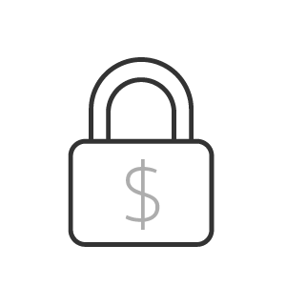 | 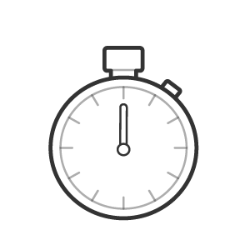 | 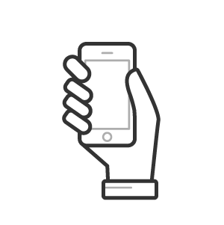
Secure  Online payments are encrypted using  bank-grade security. | Fast  Your charges are immediately marked as paid. | Convenient  You can pay your rent from anywhere you want and communicate with our team all within the online portal. | Flexible  It’s easy for you to choose the way you pay: eCheck, Debit or Credit Card, or Electronic Cash Payments
If you have any questions, please email us at shannonf@homehq.org or call (315) 459-6657.

